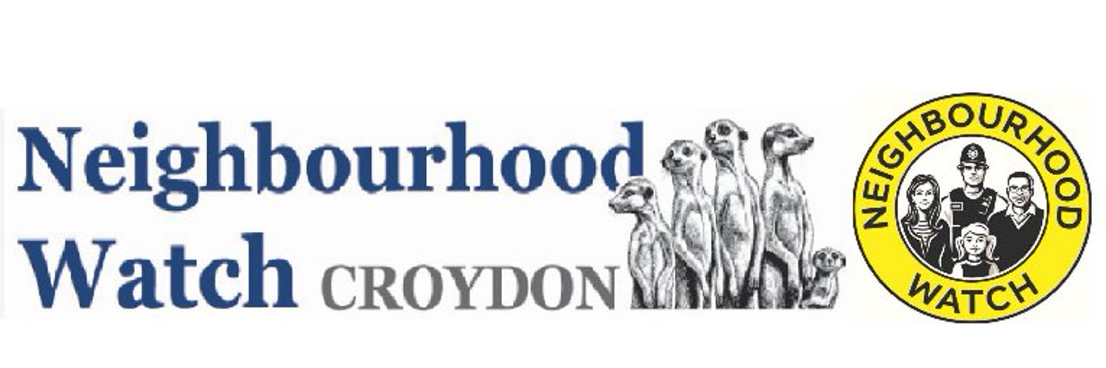
MEET THE COMMITTEE
Delicious 2 course Indian meal & Coffee (Drinks extra)
Monday 12th June 2023
7pm until 9.30pm
£20 per person

Venue: The Royal Tandoori, Selsdon
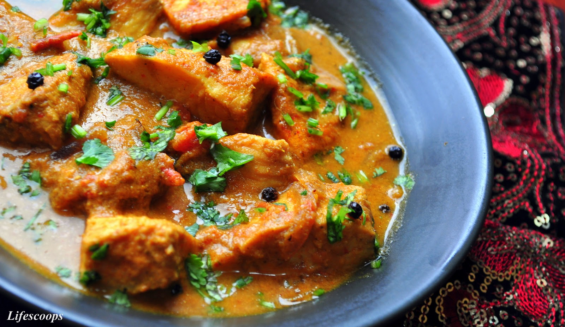
226 Addington Rd
Selsdon
South Croydon
CR2 8LD

All profit (incl. raffle) will be donated directly to Croydon Borough Neighbourhood Watch Association.

Please RSVP by email and confirm payment by Friday 12th May 2023 to nhw@cbnwa.com to confirm your place as numbers are limited.
______________________________________________________________________________________
Please quote reference: Curry Night
To pay by BACS:
Bank: Lloyds Bank; A/C Name: CBNWA; Sort Code: 30-92-45; A/C Number: 03049348
I would like………………tickets at £20.00 per person I enclose cheque(s) for £………………… made Payable to
“CBNWA”
Name…………………………………………………………… Address…………………………………………………………………..
Tel……………………………………………………………….. Email ………………………………………………………………………

