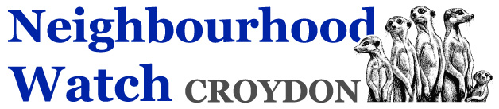

Donation’s information

As a charity with no direct funding from anyone, we rely on the generosity of members of the public to donate to our charity, if you can do so the details of the bank account to which payments can be made are below.

Charity’s Bank Details: Lloyds Bank Sort Code: 30-92-45 Account No: 03049348

We appreciate any gift you can make to ensure that Neighbourhood watch can continue to serve the community in its current capacity.

If you are also able to provide a Gift Aided donation, please do so.

We thank you on behalf of Croydon Borough Neighbourhood watch

www.cbnwa.com nhw@cbnwa.com Registered Charity number 1087760 Phone 07454 573 453
Address: CBNWA c/o Croydon Fire Station, 90 Old Town, CR0 1AR

